Park Page = lalsuhanra.html

The Benifit Of This Website Is That It Has Download Option For Information To Get Easily Read Offline In Which The Park Location , Facilities , Birds , Animals , Location & Many More

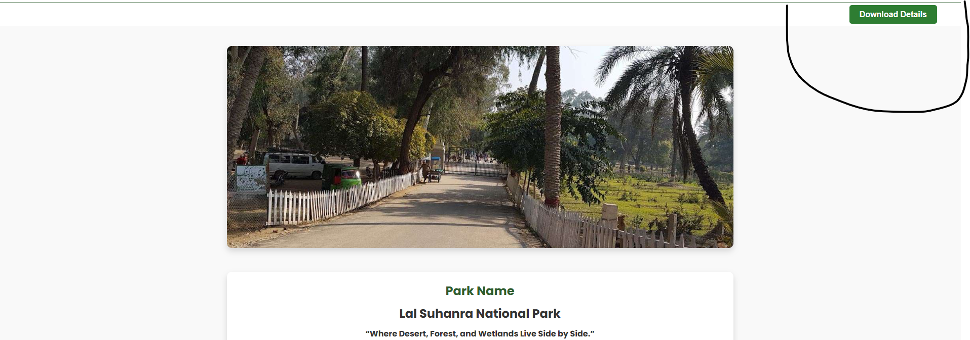

Given Mark Is Indicates To Download The Information Of Park After Coming From The Park Page

